

Introduction To Data Science

**Table of Contents**

Introduction To Data Science 2

What Data Scientists Do: 2

Paths to a Career in Data Science: 3

Essential Qualities and Skills for Data Scientists: 3

Applications of Data Science: 4

Career Development Strategies: 4

Understanding Data Formats: 4

Data Science Topics and Algorithms: 4

**Module 2: Data Science Topics** **5**

1. Digital Transformation: 5

2. Cloud Computing: 6

3. Cloud in Data Science: 6

4. Big Data Fundamentals: 7

5. Data Science and Big Data: 7

6. Artificial Intelligence and Data Science: 8

7. Machine Learning Applications: 9

8. Summary of Key Concepts: 9

**Module 3: Applications and Careers in Data Science** **9**

1. Getting Started in Data Science: 9

2. Applications of Data Science: 9

3. Impact of Data Science on Businesses: 10

4. Developing Solutions with Data Science: 10

5. Careers in Data Science: 10

6. Hiring for Data Science Roles: 10

7. Growth and Demand in Data Science: 10

8. Preparing for a Career in Data Science: 11

9. Importance of Mathematics and Statistics: 11

10. Summary of Data Science Applications: 11

### 

### Introduction To Data Science

* **Definition:** Data science is the process of using data to gain insights and make data-driven decisions. It involves exploring, manipulating, and analyzing data to uncover patterns and trends.
* **Importance:** The field has grown due to the abundance of data, accessible tools, and computing power, making it highly relevant in today’s world.

### What Data Scientists Do:

* **Role:** Data scientists are like detectives who investigate data to answer specific questions or solve problems. They use statistical methods, algorithms, and various tools to analyze data from diverse sources like social media, sales, and more.
* **Process:** The data science process includes defining the problem, collecting and analyzing data, creating models, and communicating insights through storytelling and visualization.



### Paths to a Career in Data Science:

* Data science as a distinct field emerged around 2009-2011. People enter the field through various backgrounds, including engineering, business, economics, and more.
* Exposure often happens through academic or professional experiences, with many individuals transitioning from other quantitative disciplines.

### Essential Qualities and Skills for Data Scientists:

* **Qualities:** Curiosity, analytical thinking, argumentativeness, and flexibility are key traits. Data scientists should be comfortable with analytics platforms and adaptable to different scenarios.
* **Skills:** Essential skills include data analysis, programming (Python, R, SQL), data visualization, domain knowledge, problem-solving, and effective communication. Understanding big data involves handling large volumes, variety, velocity, veracity, and extracting value.

### Applications of Data Science:

* Data scientists work on a variety of real-world problems, such as building recommendation engines, predicting environmental changes, and analyzing large datasets to find patterns.
* Example: Analyzing complaint data for the Toronto Transit Commission revealed correlations between extreme weather and high complaint days.

### Career Development Strategies:

* Focus on identifying your competitive advantage and industry of interest. Enhance skills relevant to that industry and apply them to real-world problems.
* Continuous learning and skill refinement are essential to stay competitive in the evolving data science landscape.

### Understanding Data Formats:

* Data professionals need to be familiar with different file formats like CSV, XLSX, XML, PDF, and JSON, each with its structure and use case.
* Knowing which format to use is crucial for effective data handling and analysis.

### 

### Data Science Topics and Algorithms:

* Key concepts include regression (understanding data relationships), data visualization, artificial neural networks, and distinguishing between structured and unstructured data.
* Simplified explanations help make complex topics accessible, such as using analogies to explain regression.

## Module 2: Data Science Topics

### 1. Digital Transformation:

* **Definition:** Digital transformation involves overhauling business operations through the integration of digital technologies, significantly influenced by data science and big data.
* **Impact:** It changes how businesses operate and deliver value, affecting organizational culture and requiring leadership support from roles like CEO, CIO, and Chief Data Officer.
* **Examples:** Companies like Netflix, Houston Rockets, and Lufthansa have successfully used big data for strategic improvements.



### 2. Cloud Computing:

* **Definition:** Cloud computing delivers on-demand computing resources over the internet, providing benefits like cost-effectiveness, easy access, and collaboration.
* **Deployment Models:** Includes public, private, and hybrid clouds, each catering to different organizational needs.
* **Service Models:** Comprises Infrastructure as a Service (IaaS), Platform as a Service (PaaS), and Software as a Service (SaaS), offering varying levels of management and customization.

### 3. Cloud in Data Science:

* **Benefits:** Provides centralized storage, access to advanced computing machines, deployment of algorithms, and collaborative work environments.
* **Impact on Productivity:** Cloud platforms like IBM Cloud, AWS, and Google Cloud enhance data scientists' productivity by offering pre-built environments and global accessibility.

### 4. Big Data Fundamentals:

* **Five V's of Big Data:** Velocity, Volume, Variety, Veracity, and Value represent the key attributes of big data, highlighting the speed, scale, diversity, quality, and worth of data.
* **Challenges:** Traditional data tools are often insufficient; technologies like Apache Hadoop and Spark are used for distributed data processing and analysis.

### 5. Data Science and Big Data:

* **Evolution:** Data science has evolved from handling large data volumes to incorporating advanced analytical and statistical techniques. Tools like Hadoop emerged from solving problems at companies like Google and have become key players in managing big data.
* **Key Tools:** Hadoop provides distributed storage and processing capabilities, Hive offers data warehousing, and Spark is used for real-time analytics and machine learning.

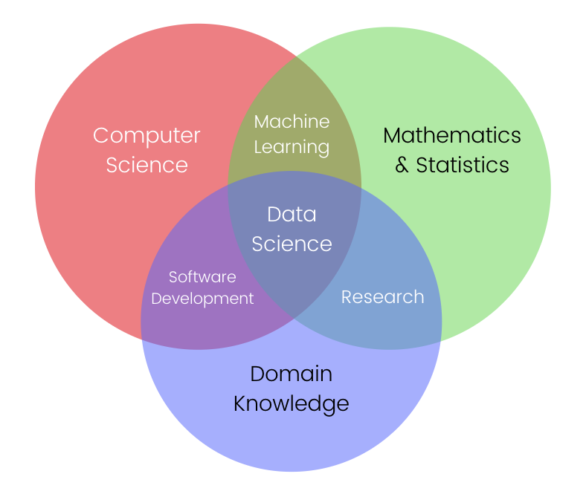

### 6. Artificial Intelligence and Data Science:

* **Neural Networks and Deep Learning:** Neural networks mimic biological systems for tasks like image and speech recognition. Deep learning, an advanced form of neural networks, uses multiple layers to tackle complex tasks and requires significant computational power.
* **Generative AI:** Creates new data, like images or text, and is used in various industries from content creation to healthcare. It also aids in generating synthetic data for model training.

### 7. Machine Learning Applications:

* **Fintech:** Machine learning is used in fintech for recommendations, predictive analytics, and fraud detection. It analyzes transaction patterns to identify suspicious activities, enhancing security and user experience.

### 8. Summary of Key Concepts:

* Digital transformation and cloud computing are crucial for modern data science practices.
* Understanding and leveraging big data require specialized tools and methodologies.
* Artificial intelligence and machine learning, including deep learning, are integral to data science, enabling advanced analytics and decision-making.

## Module 3: Applications and Careers in Data Science

### 1. Getting Started in Data Science:

* **Importance of Measurement:** For improvement in business operations, it’s crucial to measure costs, revenues, and profits. Start by capturing and archiving data consistently to ensure its relevance.
* **Team Building:** Create a diverse team of data scientists with varied expertise and interests to foster engagement and success.

### 2. Applications of Data Science:

* **Industry Examples:**
  + **Uber:** Uses real-time data to optimize driver allocation and pricing.
  + **Toronto Transportation Commission:** Utilizes data analysis to reduce traffic congestion.
  + **Healthcare:** Predictive analytics enhance patient treatment options and inform physicians of beneficial tests and treatments.
  + **Disaster Preparedness:** Data science tools predict natural disasters like earthquakes and floods, saving lives by improving early warning systems.

### 3. Impact of Data Science on Businesses:

* Data science is reshaping operations and customer interactions, with significant value derived from insights.
* Examples include recommendation engines (Amazon), personal assistants (Siri), and user preference analysis (Netflix).
* **Netflix:** Uses data to predict show success, guiding decisions on production and acquisition.

### 4. Developing Solutions with Data Science:

* **Process:** Identify the problem, gather and prepare data, choose the right tools, and develop a strategy using machine learning models. Case studies can help customize solutions and refine best practices.

### 5. Careers in Data Science:

* **Pathways:** Many high-end data scientists hold advanced degrees in fields like physics, statistics, or computer science. Essential skills include programming, algebra, calculus, probability, statistics, and database knowledge.
* **Learning:** Practical experience, online courses, and self-learning through articles and videos are critical for skill development.

### 6. Hiring for Data Science Roles:

* Companies look for "unicorns" with a mix of technical skills, curiosity, communication abilities, and a sense of humor. Technical skills vary by domain but often include proficiency in tools like Python, R, Hadoop, and Spark.

### 7. Growth and Demand in Data Science:

* Data science careers have surged, becoming highly promising since 2016, with demand across multiple industries.
* The data science platform market is expected to grow significantly by 2025, making it a critical field for future job opportunities.

### 8. Preparing for a Career in Data Science:

* **Key Skills:** Programming fundamentals, mathematical concepts, statistical analysis, and practical application through projects.
* **High School Preparation:** Encourage learning SQL, databases, and basic computer science courses. Fostering curiosity and creativity can set the foundation for a future in data science.

### 9. Importance of Mathematics and Statistics:

* Proficiency in probability, algebra, and basic statistics is essential for data scientists. Engaging in practical exercises, such as building systems and analyzing real-world data, strengthens understanding and skills.

### 10. Summary of Data Science Applications:

* Data science helps organizations achieve business goals, improve efficiency, and make informed decisions. The field impacts various sectors, including logistics, streaming services, healthcare, and disaster management, showcasing its broad applicability and potential to drive societal improvements.